**ENV-5009B – Weather Applications**

Air Mass Tracer Practical

The data overleaf represent observations or derived variables from radiosonde soundings at 14:00 on 11th January. The station locations are shown on the map. The data are Dry Bulb Temperature (T), Mixing Ratio (r), wet-bulb potential temperature (θw) and the west-east component of wind speed (u). Also indicated is the height of the tropopause. The standard pressure levels for observations have been augmented where variable gradients warrant additional information.

Using an inverted logarithmic scale of pressure for the ordinate (highest values at the bottom), construct separate vertical cross sections for T, r, θw and u. With the help of sketched contours, describe what your cross sections show and suggest a synoptic weather feature which could explain what you observe. What do your results say about the relative usefulness of each of these variables as air mass tracers?

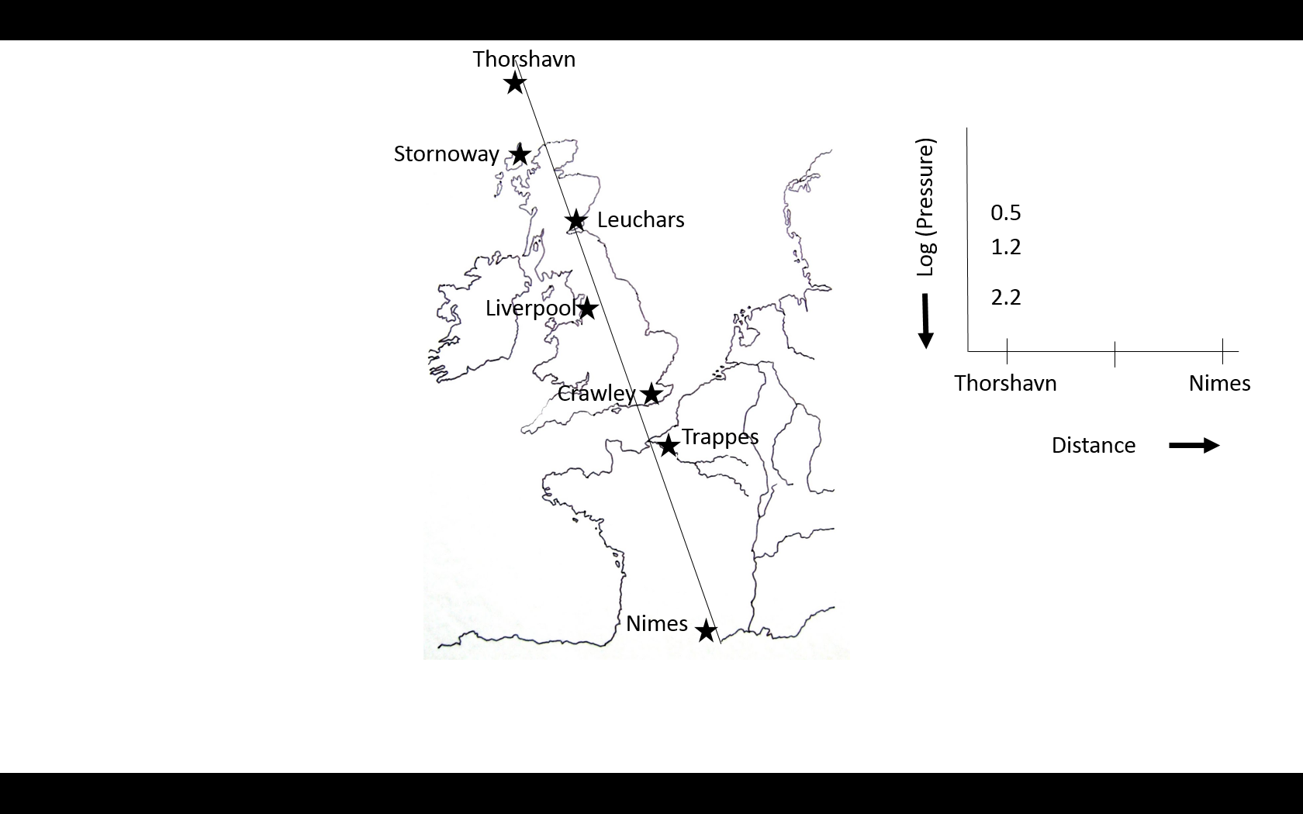

Chris Bell, 17th October 2017

|  |  |  |  |  |  |
| --- | --- | --- | --- | --- | --- |
| **Station** | **Pressure**  **P (mb)** | **Temperature**  **T (°C)** | **Mixing Ratio**  **r (g kg-1)** | **Wet-bulb Potential Temperature**  **Θw (°C)** | **West-East wind speed component**  **u (knots)** |
| Thorshavn  (Trop=370mb) | 1000  850  700  500  400  300  200 | -4.1  -14.2  -25.8  -41.3  -47.9  -52.8  -50.8 | 2.2  1.2  0.5  0.15  0.10  -  - | -5.0  -5.5  -5.5  0.0  4.4  13.0  23.2 | 5  8  13  24  27  32  31 |
| Stornoway  (Trop=430mb) | 1000  850  700  500  400  300  200 | -1.1  -10.8  -22.3  -39.4  -48.9  -48.0  -49.0 | 2.5  1.5  0.5  0.15  0.08  -  - | -1.9  -2.3  -2.3  1.2  4.1  14.0  24.5 | 8  12  16  25  34  48  40 |
| Leuchars  (Trop=410mb) | 1000  850  700  500  400  350  300  200 | 0.0  -8.8  -21.1  -37.2  -45.7  -48.0  -50.0  -48.1 | 3.0  1.7  0.2  0.15  0.09  -  -  - | -1.0  -1.2  -1.2  1.5  5.3  9.0  14.0  24.1 | 7  12  21  30  50  55  62  54 |
| Liverpool (Trop=295mb) | 1000  850  700  600  500  400  300  200 | 2.2  -8.2  -16.8  -20.0  -27.2  -37.8  -47.7  -46.8 | 3.5  1.4  0.5  0.35  0.23  0.10  -  - | 0.0  -0.5  2.0  6.1  8.0  10.2  12.1  23.0 | 0  7  21  40  53  67  82  64 |
| Crawley  (Trop=280mb) | 1000  850  700  500  400  300  270  200 | 3.0  -3.9  -8.2  -23.2  -36.1  -50.7  -56.2  -52.0 | 4.0  2.5  2.0  0.7  0.3  0.09  -  - | 1.5  3.0  8.0  10.5  12.0  13.5  15.0  23.8 | -4  3  33  56  64  70  75  71 |
| Trappes  (Trop=270mb) | 1000  850  700  500  400  300  270  200 | 11.8  4.9  -2.1  -18.8  -32.3  -50.3  -56.0  -52.9 | 8.5  6.2  3.5  0.9  0.4  0.09  -  - | 12.1  12.1  12.2  13.0  14.2  15.3  16.0  22.6 | 25  32  39  48  60  85  94  85 |
| Nimes  (Trop=200mb) | 1000  850  700  500  400  300  200 | 13.1  5.8  -2.1  -16.8  -27.0  -42.3  -57.4 | 8.0  5.5  3.0  0.9  0.4  0.15  - | 12.6  12.6  13.0  14.0  16.1  18.0  20.8 | 25  27  30  37  40  49  64 |